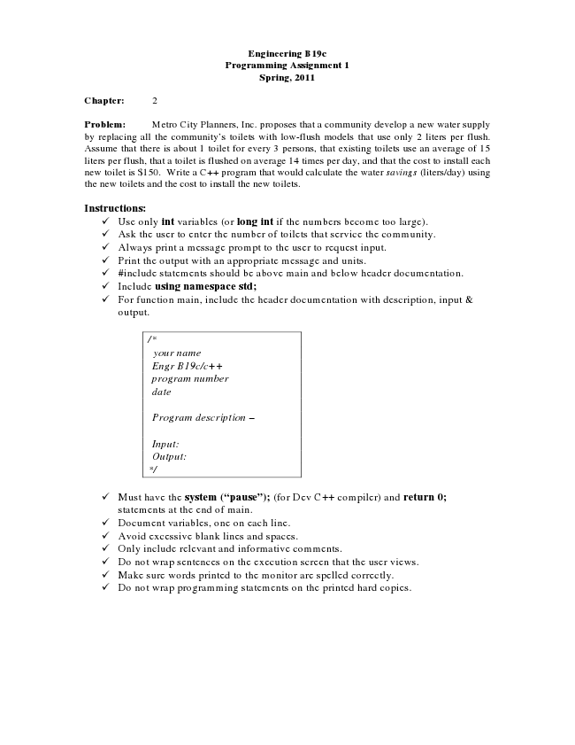

**Engineering B19c Programming Assignment 1 Spring, 2011**

**Chapter: 2**

Problem: Metro City Planners, Inc. proposes that a community develop a new water supply by replacing all the community’s toilets with low-flush models that use only 2 liters per flush. Assume that there is about 1 toilet for every 3 persons, that existing toilets use an average of 15 liters per flush, that a toilet is flushed on average 14 times per day, and that the cost to install each new toilet is $150. Write a C++ program that would calculate the water savings (liters/day) using the new toilets and the cost to install the new toilets.

**Instructions:**

✓ Use only int variables (or long int if the numbers become too large). ✓ Ask the user to enter the number of toilets that service the community. ✓ Always print a message prompt to the user to request input. ✓ Print the output with an appropriate message and units. ✓ #include statements should be above main and below header documentation. ✓ Include using namespace std; ✓ For function main, include the header documentation with description, input &

output.

*/\**

*your name Engr B19c/c++ program number date*

*Program description –*

*Input: Output: */*

✓ Must have the system (“pause”); (for Dev C++ compiler) and return 0;

statements at the end of main. ✓ Document variables, one on each line. ✓ Avoid excessive blank lines and spaces. ✓ Only include relevant and informative comments. ✓ Do not wrap sentences on the execution screen that the user views. ✓ Make sure words printed to the monitor are spelled correctly. ✓ Do not wrap programming statements on the printed hard copies.